Write field here your research topic like biology or Astrophysics
Title of the Article here (Make sure it is concise and covers the topic)
Author Name (Write first and last name), High School Name

Abstract
The abstract is brief (typically 150-300 words); the paper’s standalone summary ignites the reader’s curiosity about the topic by giving an overview of the entire paper, especially its contribution to the field. Therefore, readers can use to decide whether it's relevant to them before they dive in to read the paper. An exceptional abstract provides a brief summary of the review question being addressed or the rationale for the review, the major studies reviewed, and conclusions drawn. It also should introduce the topic, underscore its significance, highlight research gaps, articulate research aims, and outline methodologies. This compact narrative not only informs but also engages, showcasing the research's relevance and impact.

- Introduction
It establishes your writing style, the quality of your research, and your credibility as a scholar. The introduction gives the reader background and context to convey the importance of your research. The introduction’s purpose is to provide the context and rationale for the study, highlight the significance of the research question, outline the current state of knowledge, and establish the study objectives to address existing gaps or challenges in the field. An exceptional introduction must introduce the topic, describe the background (it summarizes relevant literature, outline the historical development and key studies, highlight existing knowledge, gaps, and inconsistencies, and identify areas needing further research for context.), and your rationale for addressing this topic focusing on why this topic is important. Clearly define exactly what this article will discuss and outline the order in which you will discuss each subtopic to give the reader any background information needed to understand the coming sections.
Each in-text citation in this section will be labeled by the number corresponding to its place in the references table below. For example, pain receptors are known for their importance [1]. To mention figures, you can follow the following example.
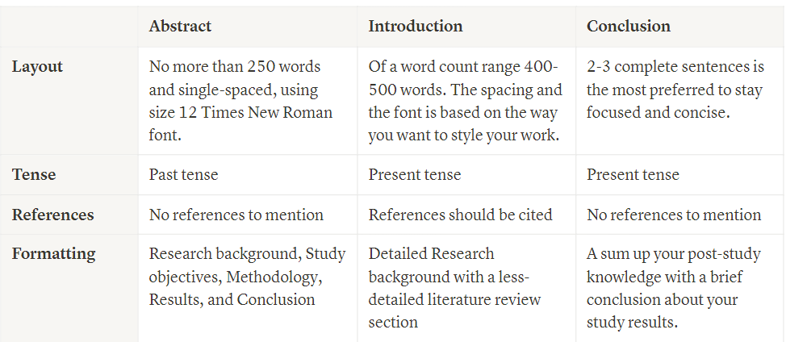
Figure (1) summarizes the characteristics of the abstract, introduction, and conclusion.
Figure 1: compares the Abstract, the introduction, and the conclusion [if you cited the source in your references, you could make in-text citations otherwise use the format below].
Source: Youth Science Journal research program curriculum, 2023
- Methods
The methods section must answer two questions: how did you conduct your research? and why did you choose the methods that you used?
Here, you can demonstrate that your research was conducted rigorously and is replicable. Illustrating how you addressed and overcame biases adds legitimacy to your work and situates it within your field. Providing references allows readers to verify your research and address any questions or critiques they might have about other sections.
An exceptional methodology should contain the following:
- Criteria for selecting studies.
- Search strategy and sources.
- Methods for data extraction and synthesis.

- Main body
- Thematic or Topic-Based Sections: Organization of the body into themes, trends, or subtopics. (you can figure out the organization for your paper, but the mentioned are the most common ones)
- Thematic organization involves dividing the review into sections based on overarching themes or major concepts related to the topic. Its purpose is to group related studies or findings under specific themes, making it easier to compare different aspects of the topic.
- The Trend-Based organization organizes the review based on observed trends over time, such as changes in research focus or technological advancements. Its purpose is to highlight the evolution of the field and how certain trends have influenced current understanding.
- Summary of Findings: Discussion of key studies, their contributions, and their impact.
- You may also discuss the summary of the methodology of different studies.
- Critical Analysis: Evaluation of the quality and relevance of the studies reviewed.
- Section Heading
You can add as many of these sections as you want and label them as you want. These sections will act as your main body of the article, where you can discuss the main topics. For example, you could have a section describing a certain researcher’s findings, biological mechanisms or phenomena. Make sure to use in-text citations and a lot of references to your claims.
If you want to divide your section into even more parts, then you can use this style for it. Remember, this is optional. Like this:
- Example Sub-Section Heading
Then, you can add as many sub-sections as you would like using this style to your article.
- Example Sub-Section Heading
You can add as many of these sections as you want and label them as you want. These sections will act as your main body of the article, where you can discuss the main topics. For example, you could have a section describing a certain researcher’s findings, biological mechanisms or phenomena. Make sure to use in-text citations and a lot of references to your claims.
- Example Sub-Section Heading
You can add as many of these sections as you want and label them as you want. These sections will act as your main body of the article, where you can discuss the main topics. For example, you could have a section describing a certain researcher’s findings, biological mechanisms or phenomena. Make sure to use in-text citations and a lot of references to your claims.

- Discussion
The discussion must contain the description, analysis, and interpretation of the findings. The discussion should explain the significance of those results and tie everything back to the research question(s). An exceptional discussion should do the following:
- Summarize the key findings from the research and link them to the initial review question.
- Interpretation of the findings.
- Identification of gaps or limitations in the current research.
- Mention some recommendations (especially, the recommendations that can address the limitations or weaknesses of the research)

- Conclusion
A conclusion is the final paragraph (250 – 300 words) of a research paper and serves to help the reader understand why your research should matter to them. The conclusion should restate your topic and why it is important, restate your review question, and include a call for action or overview of future research possibilities. An effective review paper conclusion should contain a recap of the main findings and final thoughts on the state of knowledge and its importance and leave a final impression on the reader.
- References
- For example : J. Alonso, M. Petukhova, G. Vilagut, S. Chatterji, S. Heeringa, T. Ustun and A. Alhamzaw, "Days out of role due to common physical and mental conditions: results from the WHO World Mental Health Surveys," Molecular Psychiatry, pp. 1-13, 2010.
- Use IEEE citation style to cite your references here.
- Use IEEE citation style to cite your references here.
- Use IEEE citation style to cite your references here.
- Use IEEE citation style to cite your references here.

You should keep in mind the following points while conducting your research.
- Ethical consideration
The importance of ethics in research cannot be neglected, as it is crucial for maintaining the credibility, trustworthiness, and social accountability of a study. Researchers have a responsibility to adhere to ethical standards to protect the rights and well-being of participants, ensure data accuracy, and maintain public confidence in scientific investigations. To uphold these values, researchers should obtain informed consent from participants, ensuring they fully understand the study's objectives, procedures, and potential risks. It is essential to prioritize confidentiality by securely storing and anonymizing data. Additionally, researchers must avoid conflicts of interest by disclosing any affiliations or funding sources that could influence the study's findings. Moreover, research should aim to minimize harm and avoid deceptive practices. Key ethical principles from Institutional Review Boards (IRBs) include promoting voluntary participation and reducing risks for participants. Voluntary participation emphasizes the importance of individuals willingly choosing to engage in the study without coercion. Minimizing risks involves designing the research to mitigate potential harm as much as possible. Adhering to these guidelines not only protects participants but also enhances the credibility and societal relevance of the research. By following these principles, researchers contribute responsibly to advancing knowledge while honoring human dignity and ethical standards.
- Peer Review
The peer review process is a critical component of academic publishing, ensuring the quality and credibility of research. In this process, experts in the field evaluate a manuscript's methodology, significance, and clarity. Authors receive feedback, which can range from minor suggestions to major revisions. When responding to reviewer comments, it is essential to address each point thoughtfully and respectfully. A clear and detailed response letter should accompany the revised manuscript, highlighting the changes made and justifying any differences in opinion. This dialogue helps refine the work and contribute to the overall integrity of scientific literature.
Previous example published in our journal (Click on the paper title to read the paper)
- “A Comparative Study of the Perceived Stress Levels and Sources of Stress among STEM and Conventional Students in Egypt”
1. Research Type:
The research is quantitative as it involves the collection and statistical analysis of numerical data to compare stress levels among students.
2. Research Design Type:
The study uses a comparative design, as it aims to compare stress levels between STEM and conventional students. The data collection method was an online survey.
3. Literature Review Type:
The literature review includes a synthesis of previous studies on academic performance, stress, extracurricular activities, and social interactions among high school students. It references various research findings and experiments to provide context for the current study.
3. Data analysis method:
Data were analyzed using statistical methods, primarily with the Statistical Package for the Social Sciences (SPSS) version 25. The analysis involved descriptive statistics and inferential statistics, such as independent sample t-tests, chi-square tests, Mann-Whitney tests, one-way ANOVA, and Spearman's correlation coefficient tests.
- “Ultimate security by combining Cloudflare's and Akamai's APIs and machine learning”
1. Research Type:
Applied Research: The paper focuses on developing a practical solution for enhancing security by combining Cloudflare’s and Akamai’s APIs with machine learning.
2. Research Design Type:
Experimental Design: The study involves implementing and testing different machine learning models (e.g., XGBoost) to achieve the highest accuracy in detecting suspicious IPs.
3. Literature Review Type:
Narrative Literature Review: The paper discusses the background and relevant technologies, such as APIs, Cloudflare, Akamai, and various machine learning algorithms, to provide context and justification for the study.
3. Data analysis method:
Quantitative data analysis: This is evident from the use of machine learning algorithms (such as XGBoost) to analyze numerical data, specifically IP addresses, and classify them as safe or suspicious.
- “A genetic approach for tackling sickle cell disease”
1. Research Type:
The research is quantitative as it involves the collection and statistical analysis of numerical data on sickle cell disease (SCD) complications and treatment outcomes.
2. Research Design Type:
The study employs a descriptive research design, focusing on detailing the complications and treatments of sickle cell disease. Data collection methods include literature review and analysis of existing medical data.
3. Literature Review Type:
The literature review consists of a comprehensive synthesis of previous studies on sickle cell disease, including its history, pathophysiology, complications, and treatments. It references historical discoveries, experimental findings, and recent advancements in gene therapy and medication.
3. Data analysis method:
Data were analyzed using qualitative methods to compare the effectiveness of treatments like hydroxyurea and gene therapy. The paper discusses various studies and their findings rather than employing new statistical analyses.

